Preliminary AI Driven Pertussis Modeling Proof Of Concept

Version 0.5
4/22/2026

International Responder Systems
Mark Routson, Youssef Ziouani, Dr. Ryan Avery, Anibal Cruz, Emma Hapler

Change Log
Date | Change Description | Author
4/22/2026 | Initial document | Mark Routson

Contents
Version 0.5 1
International Responder Systems 1
Change Log 2
Background 3
Approach 4
Compartmental Model 7
Compartments Definitions 8
Transition Edges Defined 9
Model Parameters Defined 10
Readme File 11

Background
Oregon’s Lane County has had a re-occuring surges in Pertussis over the last few years, and wants to see if there is a way to simulate/aid in predicting cases. We applied Anthropic to generate initial ideas and code for this specification. This will be evolved with engagement of Epydemix architect (Nicolo Gozzi), IRS Development Team (Youssef Ziouani, Mark Routson, Chris Zhu) and IRS CFA team, Dr. Ryan Avery, Anibal Cruz, Emma Hapler.
The intent of this is to drive two outcomes:
- Generate a feasible pertussis model for Oregon Lane county, calibrated against their actual case count data.
- Explore generation of compartmental models using AI assisted technology, Anthropic in this case.

Approach
We are envisioning modeling it as an SEIR model with rounds of vaccination related to CDC recommendation of dTAP 5 round series, as depicted below:

Pertussis (whooping cough) has some important epidemiological features that shape the right model structure:
- Waning immunity — both vaccine-induced and natural immunity fade over time, so recovered individuals can become susceptible again.
- Partial immunity — previously exposed/vaccinated individuals who get reinfected tend to have milder, shorter illness and are less infectious.
- Incubation period — there's a 7–10 day latent period before becoming infectious, so an E (Exposed) compartment is needed.
- Vaccination — a large portion of the population starts with vaccine-derived partial immunity.
The correct model is an SEIRS variant with partial immunity, often written as S → E → I → R → S with a parallel partially-immune track. The standard in the literature (e.g. Wearing & Rohani 2009) is:
Created a file, read a file
Created a file, read a file
R
read_me
The correct structure is an SEIRS model with a parallel partial-immunity track — 8 compartments total. Here's a breakdown of each and why it's needed:
Naive track (blue — S → E → I → R)
- S — fully susceptible individuals, never infected or vaccinated
- E — exposed but not yet infectious (latent period ~7–10 days, rate ε)
- I — fully infectious with classic whooping cough symptoms
- R — recovered with strong but temporary immunity
Partial immunity track (teal — Sₚ → Eₚ → Iₚ → Rₚ) This is what distinguishes Pertussis models from simpler SEIRS models:
- Sₚ — susceptible but with partial protection (vaccinated or previously recovered); reduced susceptibility by factor δ < 1
- Eₚ / Iₚ — shorter, milder illness; reduced onward infectiousness by factor σ < 1 (Iₚ cases are often the undiagnosed adult reservoir)
- Rₚ — recovered with partial immunity, which also wanes
Key connecting flows:
- ν (vaccination): moves S → Sₚ at birth or via booster campaigns
- ω₁ (waning, full → partial): R loses sterilizing immunity but retains partial protection → Sₚ
- ω₂ (waning, partial → susceptible): Sₚ/Rₚ eventually lose even partial protection → S
- Force of infection: both I and σIₚ drive transmission, but Iₚ contributes less (σ < 1)
Why not simpler? A basic SIR or SEIR misses the adult booster dynamic — the Iₚ compartment is the reason Pertussis persists in highly vaccinated populations despite high coverage. The partially immune Iₚ individuals are often the ones silently transmitting to unvaccinated infants.

Compartmental Model
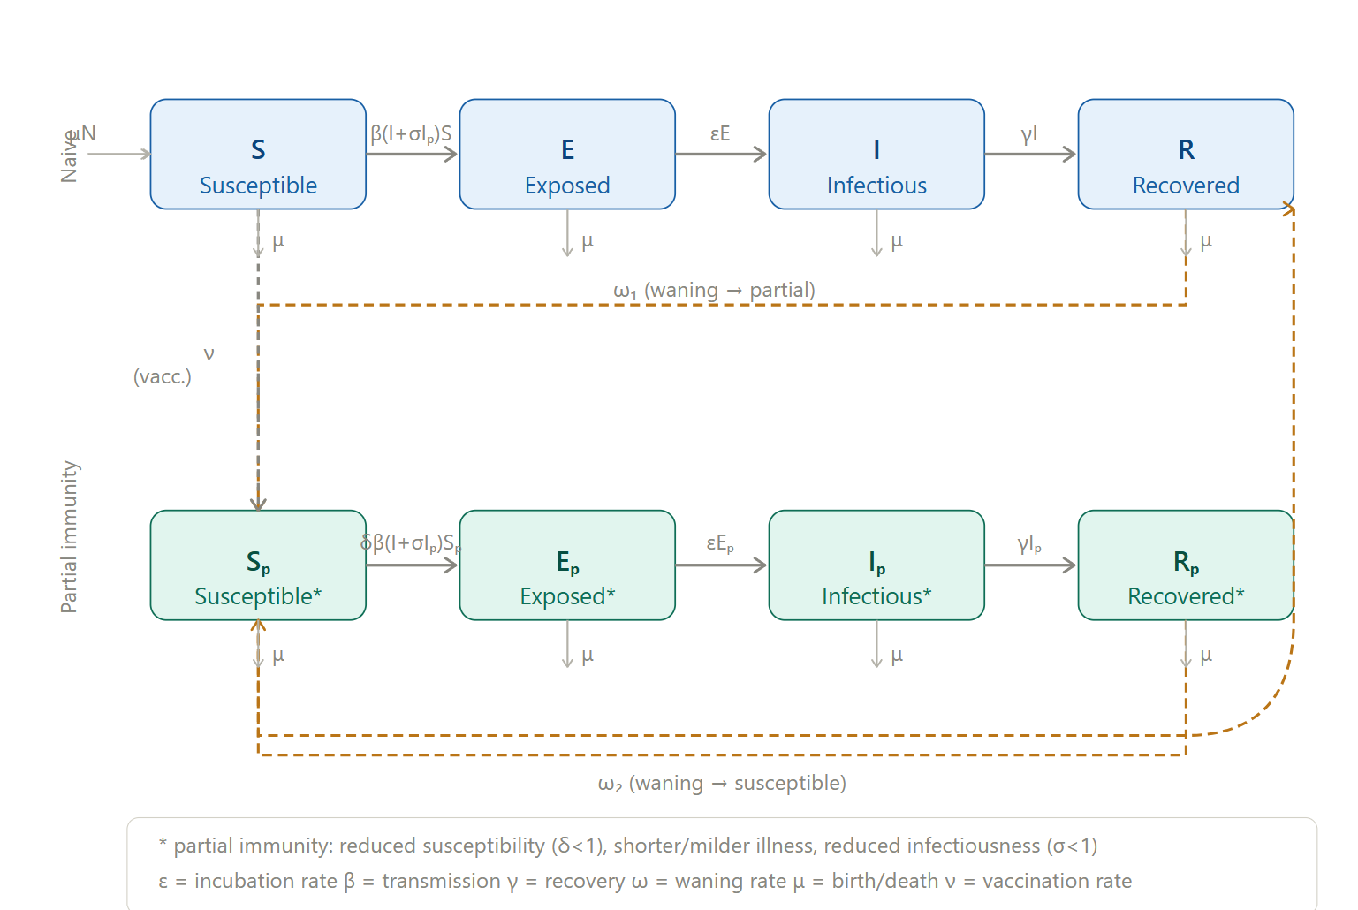

Compartments Definitions
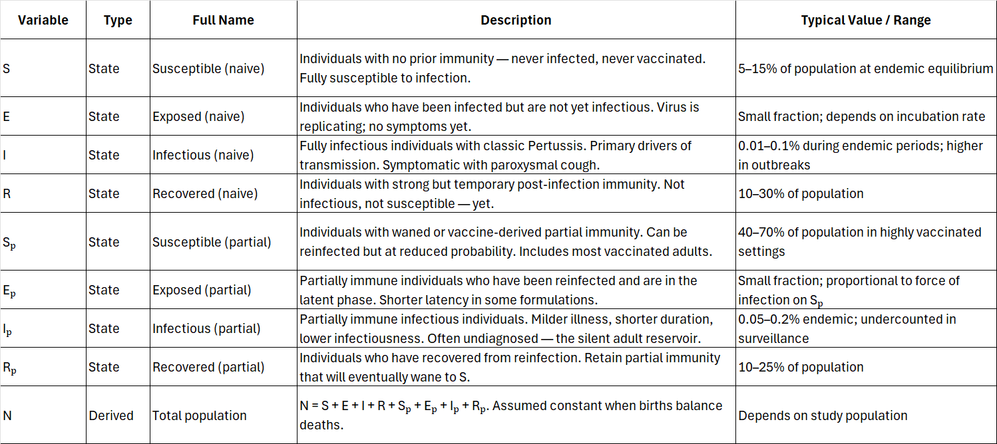

Transition Edges Defined
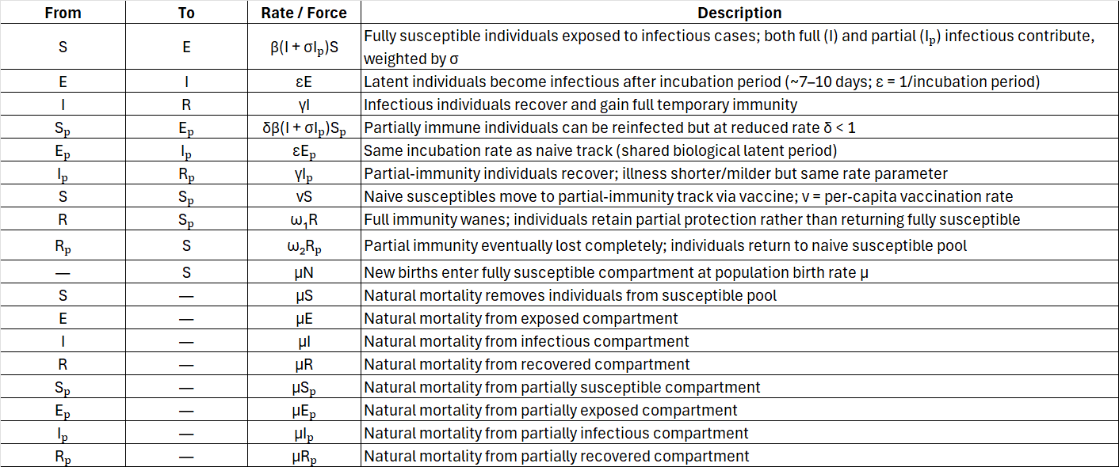
One important modeling note: some formulations split γ so that Iₚ recovers faster than I (partial immunity shortens illness duration), giving Iₚ its own γₚ > γ. Whether you use a shared or separate recovery rate depends on how precisely you want to capture the milder clinical course in the partial-immunity track.

Model Parameters Defined
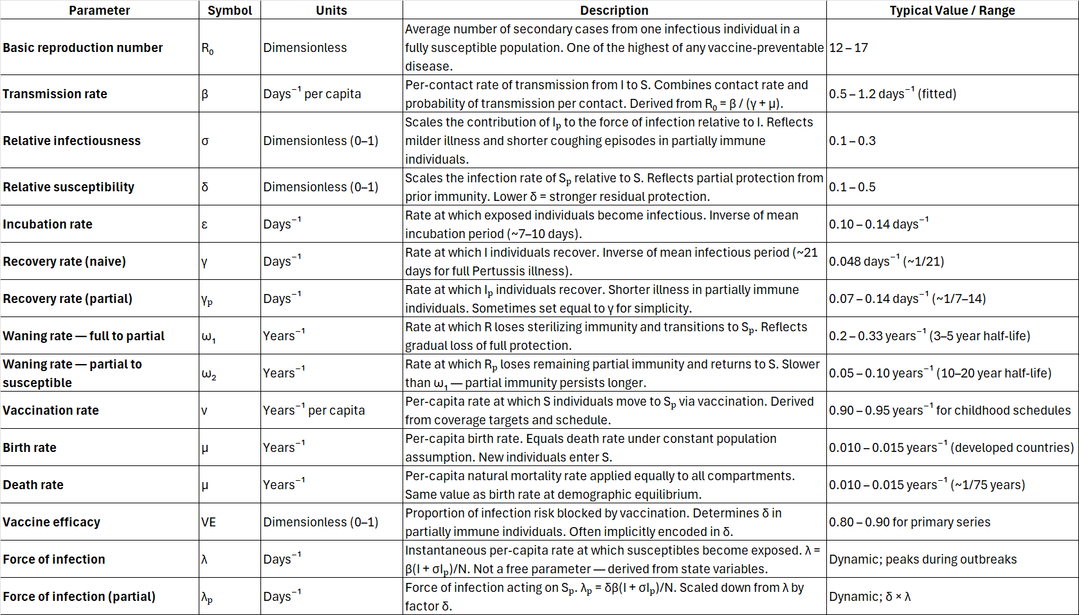

Readme File
The script is fully self-contained and maps directly to everything we defined in the model. Here's a walkthrough of the key sections:
Section 1–2 — Compartments & parameters. All 8 compartments and every parameter from our variable table are declared up front, with values and units annotated in comments.
Section 4 — Transitions. This is the most important part. Epydemix uses two transition kinds: mediated for rates that depend on another compartment (the force of infection), and spontaneous for rates that depend only on the source compartment (recovery, waning, vaccination). GitHub Because epydemix's mediated type only accepts a single mediating compartment, the combined force of infection β(I + σIₚ) is split into two separate transitions — one mediated by I and one by Iₚ with the scaled rate β·σ.
Section 5 — Derived parameters. The compound rates (beta_sigma, beta_delta, beta_delta_sigma) are pre-computed and registered as named parameters so the transitions can reference them cleanly.
Section 6 — Initial conditions. The population starts in an endemic state with ~65% in Sₚ (the vaccinated adult pool), seeded with 10 naive and 5 partially-immune index cases. This reflects real Pertussis dynamics where most of the population carries partial rather than full immunity.
Section 9 — Visualisation. Three panels: active infectious cases (I vs Iₚ), susceptible pools (S vs Sₚ), and recovered pools (R vs Rₚ), all with 90% confidence intervals across the 200 stochastic replicates.

